**VPM's K.G. Joshi College of Arts and N.G. Bedekar College of Commerce (Autonomous), Thane**

**Activity Report**

**1. Title of the activity – संस्कृतदिनम्- रचयामोनवमितिहासम् | इति संकल्पनाधारितम|**

**2. Name of the Departments - Department of Sanskrit**

**3. Day and Date - 23rd September 2024**

**4. Name of Resource Person - Dr. Namrata Jadhav, Ruia College.**

**5. No. of students benefited - Male -10 Female-18  Total-28**

**6. Purpose of the Activity:- The celebration of Sanskrit Day in college, with the involvement of parents and other viewers, serves several meaningful purposes. The event showcases the cultural richness and linguistic heritage of Sanskrit, engaging both students and the broader community in its preservation and promotion.**

**Key purposes include:**

1. **Promoting Sanskrit Language and Culture  
    The primary goal is to foster a deeper understanding and appreciation of Sanskrit, one of the oldest languages in the world. Through drama, dance, songs, and performances, students showcase the language's beauty and versatility, making it relevant and exciting for all age groups.**
2. **Strengthening the Teacher-Student-Parent Connection  
    By inviting parents and other viewers, the celebration creates a collaborative space where families can experience and support their children's educational journey. It strengthens the bond between students, educators, and parents while highlighting the importance of cultural and academic events.**
3. **Encouraging Student Creativity and Confidence  
    Through performances in Sanskrit, students get the opportunity to showcase their creativity, language skills, and cultural knowledge. This also builds confidence in speaking, performing, and interacting in Sanskrit, encouraging a sense of pride in their heritage.**
4. **Fostering Community Involvement and Awareness  
    Inviting parents and other viewers makes the celebration more inclusive, encouraging broader community participation. It also helps raise awareness about the significance of Sanskrit in Indian culture and history.**
5. **Celebrating India's Literary and Cultural Heritage  
    By presenting a variety of performances like drama, dance, and songs in Sanskrit, the event brings to life the traditional art forms that have shaped India's cultural landscape for centuries.**
6. **Promoting Interdisciplinary Learning  
    Students get the chance to connect different fields such as theater, music, dance, and literature with language, making learning more holistic and engaging.**

**7. Gist of the Activity: Sanskrit Day Celebration in College**

**The Sanskrit Day celebration in college, with participation from parents and other viewers, aims to promote and appreciate the rich cultural and linguistic heritage of Sanskrit. Students present a variety of performances, including drama, dance, songs, all in Sanskrit, showcasing the beauty and significance of the language. The event fosters creativity, confidence, and a sense of pride among students while engaging the community in the preservation of Sanskrit. It also strengthens the connection between students, teachers, and parents, while celebrating India’s literary and cultural legacy.**

**Teacher Incharge :-  Asst. Prof. Swati Bhalerao / Asst. Prof. Rohini Joshi**

**Thanks and Regards**

**Asst. Prof. Swati M. Bhalerao  Dr. Suchitra A. Naik**

**HoD Sanskrit Principal**

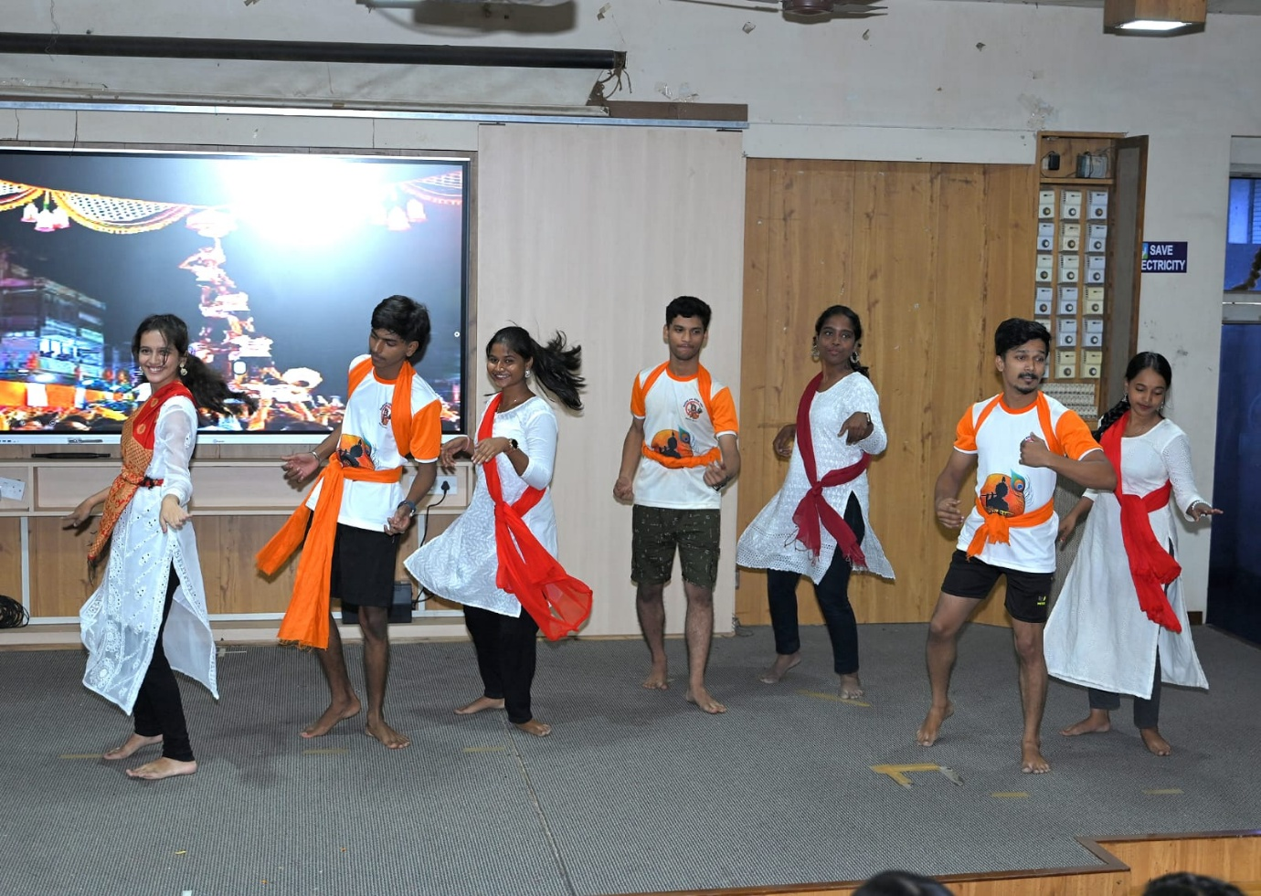

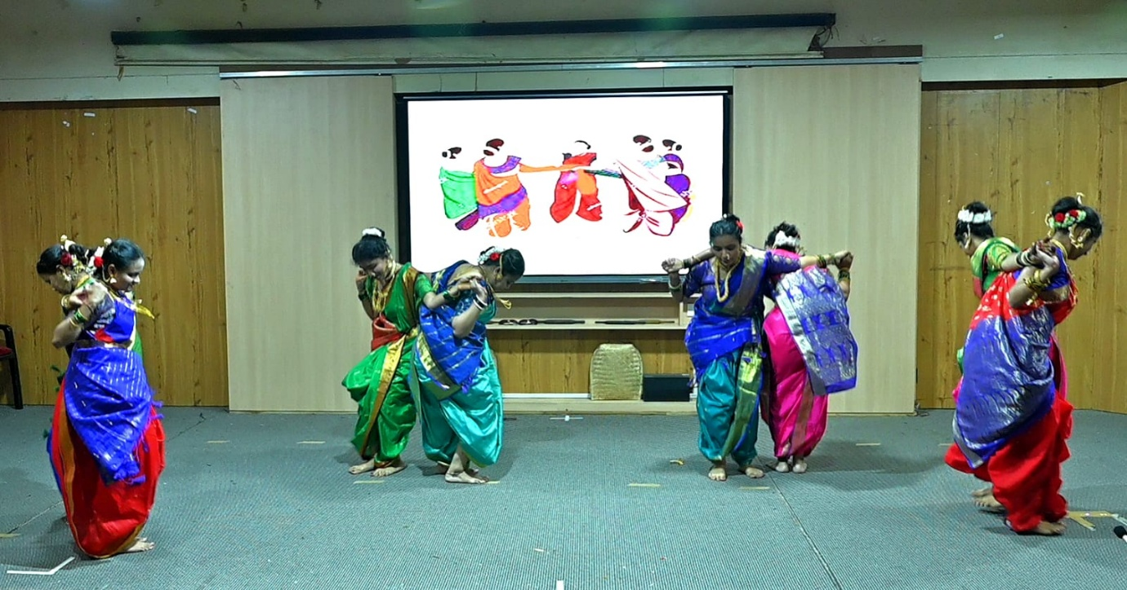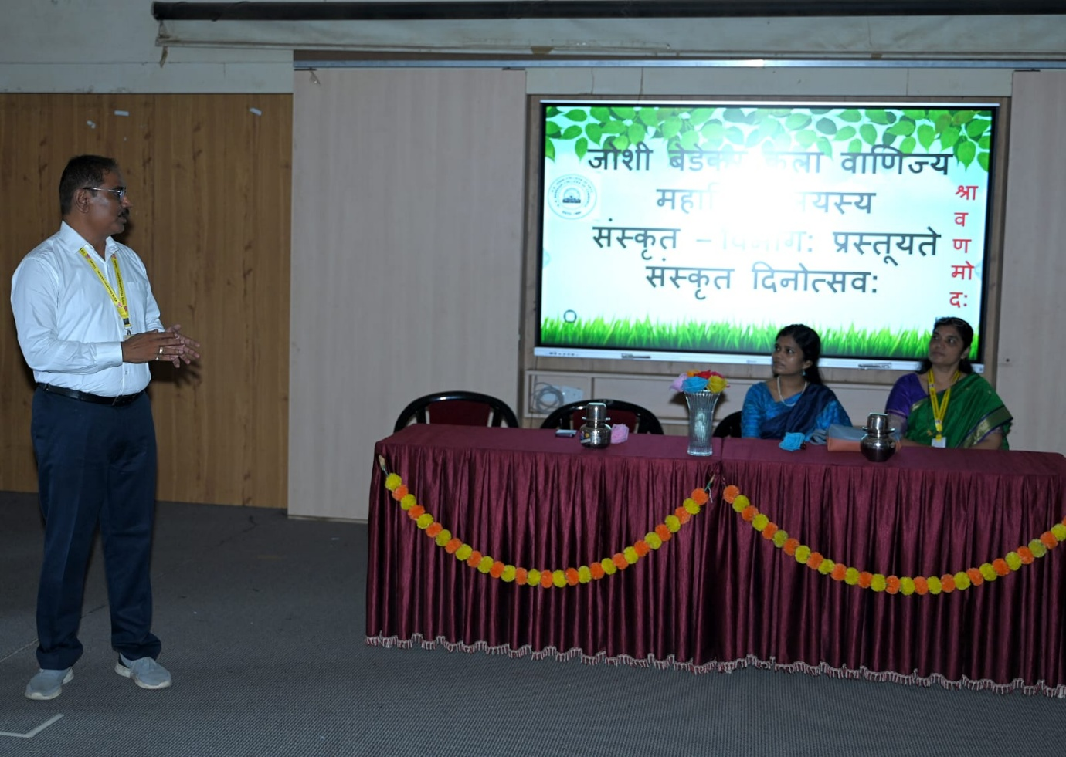

**SANSKRIT DAY CELEBRATION  23rd September 2024**